COMP 2714

aSSIGNMENT 4

NORMALIZATION RELATIONAL MODEL

**QUESTION 1**

**UNF**

**orderForm**(OrdNo, OrdDate, OrdName,OrdStreet, OrdCity, OrdState, OrdZip, CustNo, CustFirstName,CustLastName,CustStreet, CustCity, CustState, CustZip, EmpNo, EmpFirstName, EmpLastName, [ProdNo, Product, SuppNo, Supplier,Qty, Price, Amount], TotalAmount)

**1NF: Resolve the repetitive groups**

**orderForm**(OrdNo, OrdDate, OrdName, OrdStreet, OrdCity, OrdState, OrdZip,CustNo, CustFirstName, CustLastName,CustStreet, CustCity, CustState, CustZip, EmpNo,EmpFirstName, EmpLastName, TotalAmount)

**OrderDetails**(ProdNo, OrderNo(FK), SuppNo, Product, Supplier, Qty, Price, Amount)

**2NF - Resolve partial Dependency**

**Order**(OrdNo, OrdDate, OrdName, OrdStreet, OrdCity, OrdState, OrdZip, EmpNo, EmpFirstName, EmpLastName, CustNo, CustFirstName, CustLastName, CustStreet, CustCity, CustState, CustZip, TotalAmount)

**ProductDetails**(ProdNo, Product, Price)

**OrderDetails**(ProdNo[FK],Product, SuppNo, Supplier, Qty, Amount)

**3NF - Resolve transitive dependency**

**Order(**OrdNo, EmpNo[FK], CustNo[FK], OrdDate, OrdName, OrdStreet, OrdCity, OrdState, OrdZip, TotalAmount)

**Customer**(CustNo, CustFirstName, CustLastName, CustStreet, CustCity, CustState, CustZip)

**OrderDetails**(OrdNo[FK], ProdNo[FK], Qty, Amount)

**ProductDetails** (ProdNo, SuppNo[FK], Product, Price)

**Employee**(EmpNo, EmpFirstName, EmpLastName)

**SupplierDetails**(SuppNo, Supplier,)

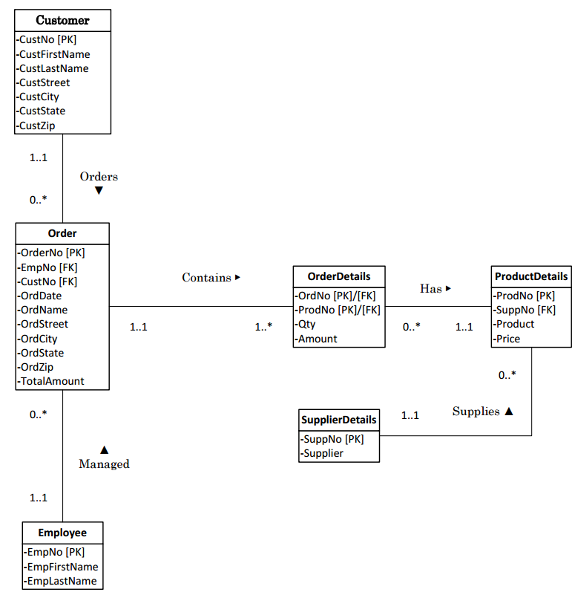**ER Diagram for an order form**

**QUESTION 2**

**UNF**

**Invoice**(InvoiceNo,CustNo,Name,Date,Address,OrderNo,[ProductNo,

Description,QtyOrd,QtyShip,QtyBack,UnitPrice,TotalPrice],

TotalAmount,Discount,AmountDue)

**1NF - Resolve the repetitive groups**

**Invoice**(InvoiceNo, OrderNo,CustNo, Name, Date, Address, TotalAmount,

Discount, AmountDue)

**InvoiceDetails**(InvoiceNo[FK], ProductNo, Description ,QtyOrd,QtyShip, QtyBack, UnitPrice, TotalPrice)

**2NF - Resolve partial Dependency**

**Invoice**(InvoiceNo, CustNo, Name, Address, OrderNo, Date, TotalAmount, Discount, AmountDue)

**Product**(ProducNo, Description, UnitPrice);

**InvoiceDetails**(InvoiceNo[FK], ProductNo, QtyOrd, QtyShip, QtyBack, UnitPrice, TotalPrice)

**3NF - Resolve Transitive Dependency**

**Invoice**(InvoiceNo, CustNo[FK], OrderNo, Date, TotalAmount, Discount)

**Customer**(CustNo, Name, Address)

**InvoiceDetails**(InvoiceNo[FK], ProdNo[FK], QtyOrder, QtyShip, QtyBack, TotalPrice)

**Product**(ProductNo, Description, UnitPrice)

**ER Diagram for an invoice**

